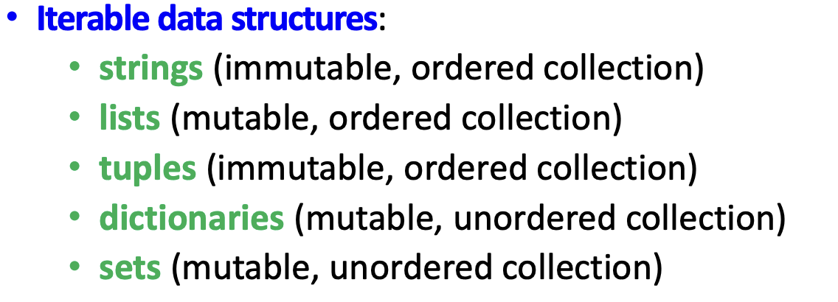

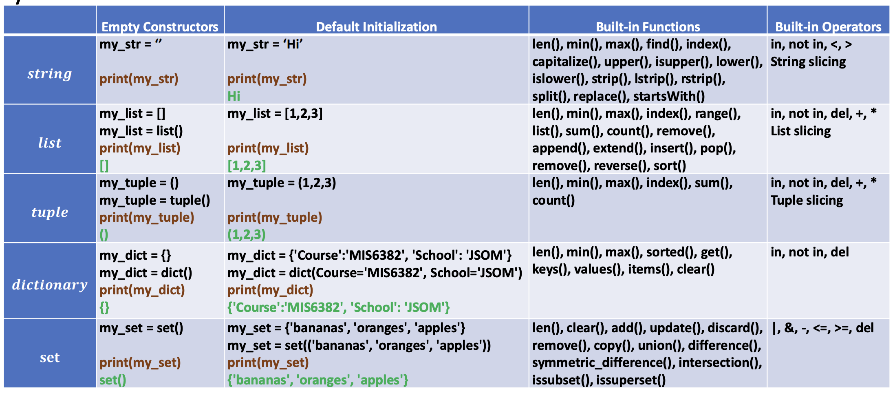

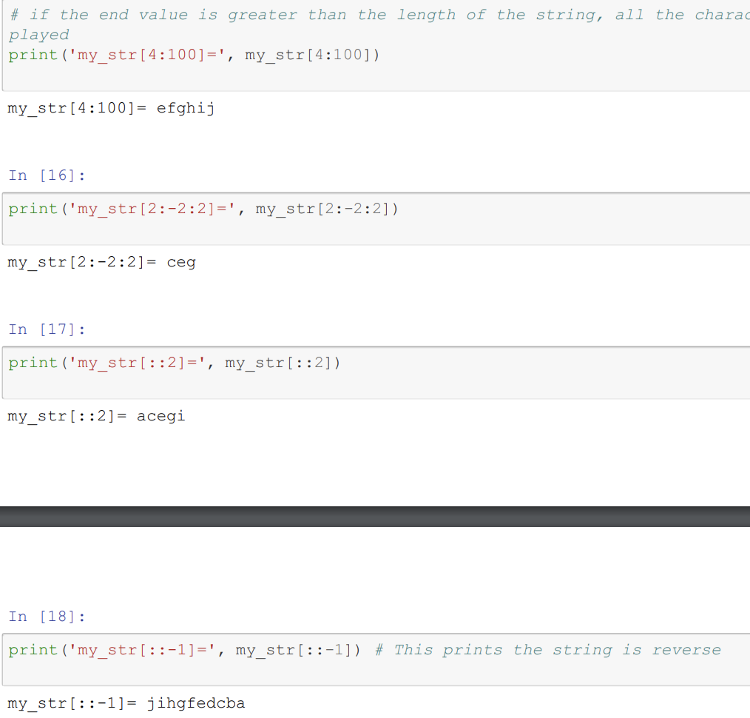

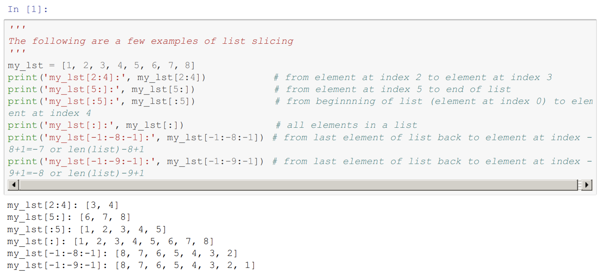

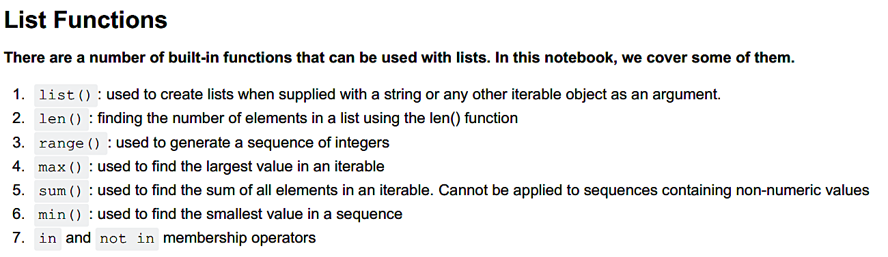

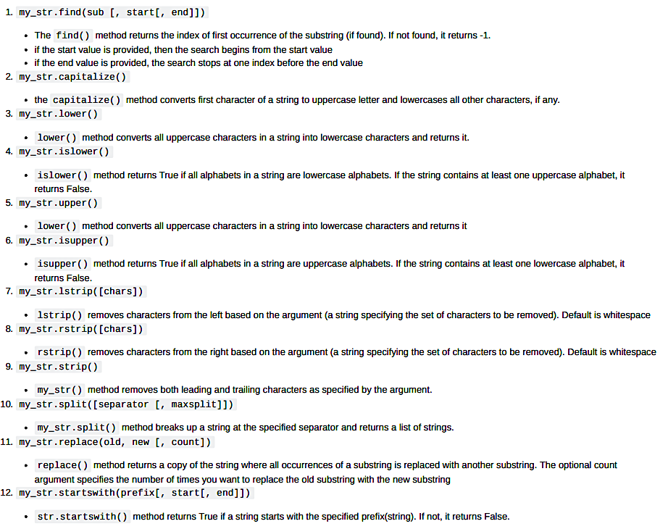

Note that in find function if cannot find the string the o/p will be -1

Split returns list.

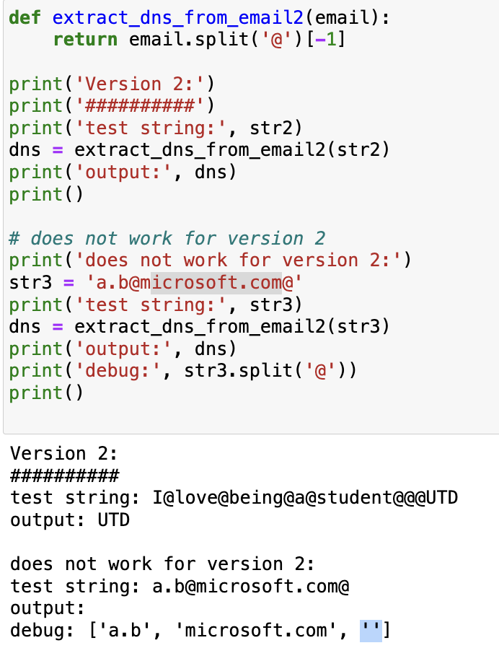

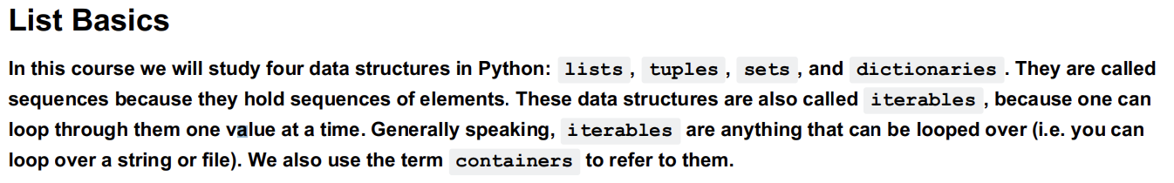

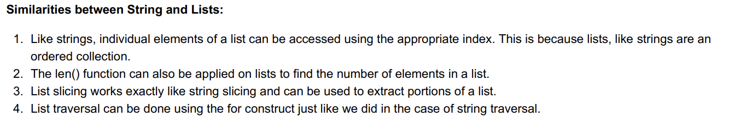

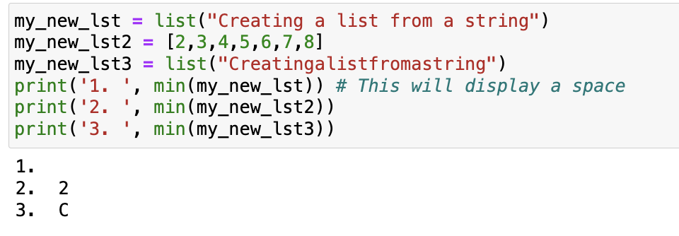 space is the smallest in min

List can also be modified using list slicing. This is known as slice assignment and is done by using an appropriate slice

expression on the left hand side of the assignment operator. In this notebook, we discuss a few possibilities. Note that slice

assignment is only applicable with mutable objects like lists. Although tuple slicing and string slicing can be done, slice

assignment is not possible with strings and tuples since they are immutable objects.

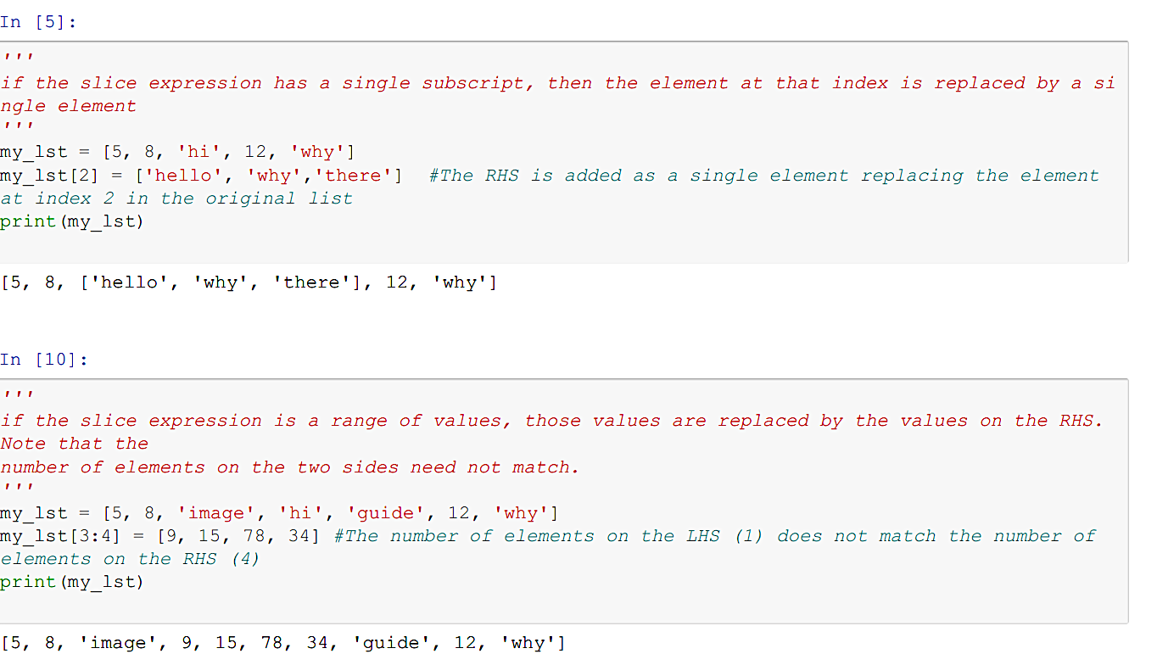

If list slice is used to replace one index or range of index difference

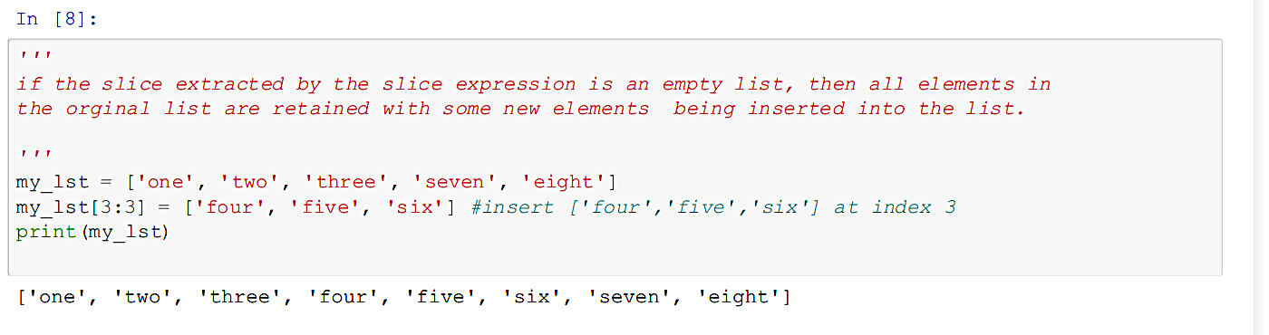

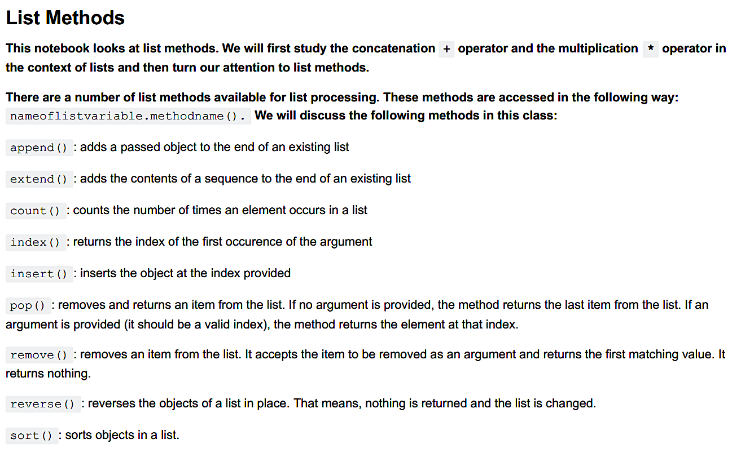

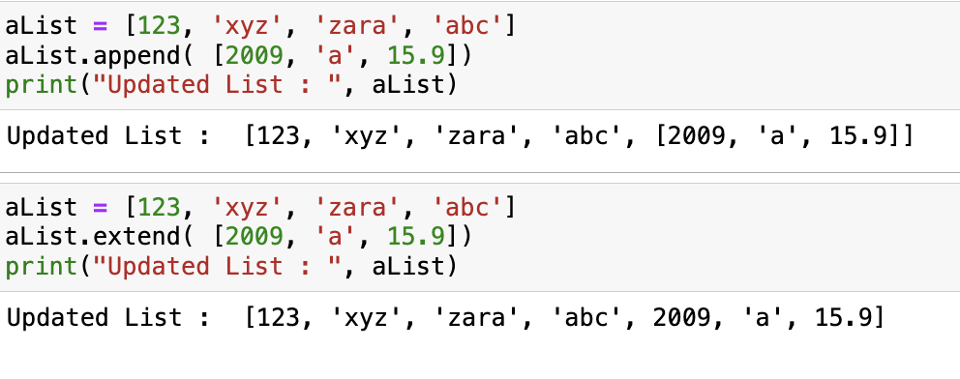

The insert() method inserts the object at the index provided. The first argument is the index at which the second

argument is to be inserted. This method modifies the original list.

**Can pop be used in stack,queue**

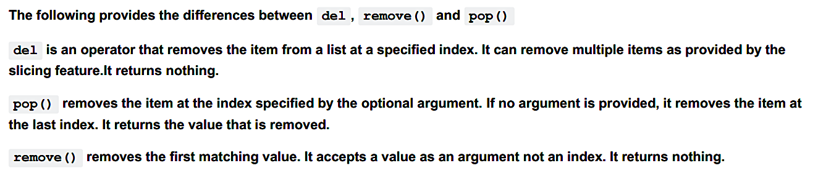

The sort() method sorts the objects of a list in place. Nothing is returned and the list is changed. Note that all elements

of the list have to be of the same type. Having a mix of elements will cause an

error**.**

**Append and extend takes only 1 argument , so if u want to pass more values**

**do it in list or tuple**

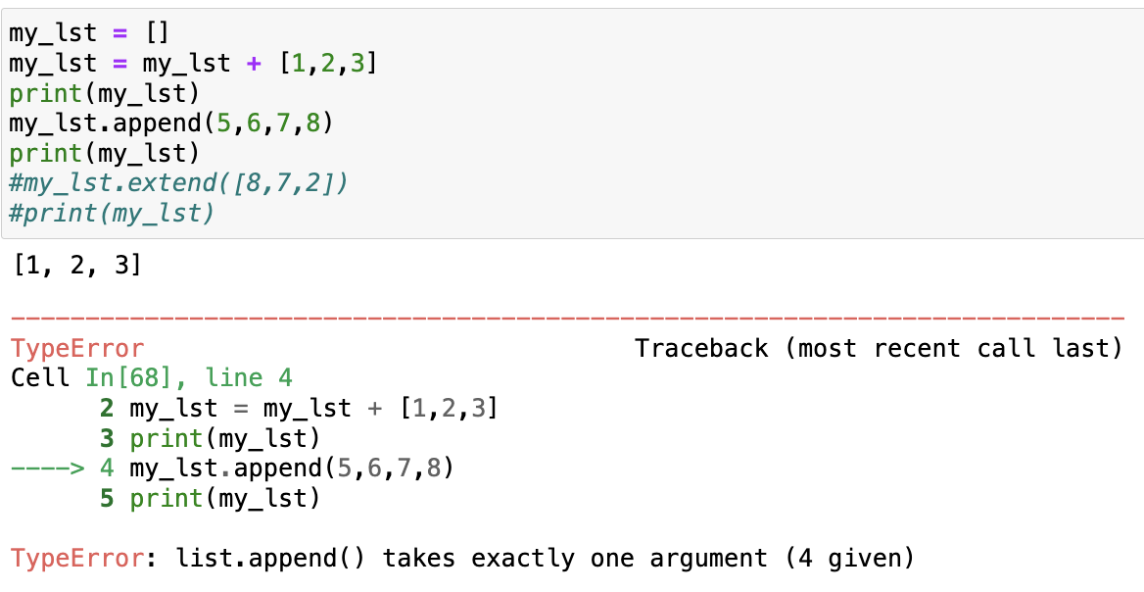

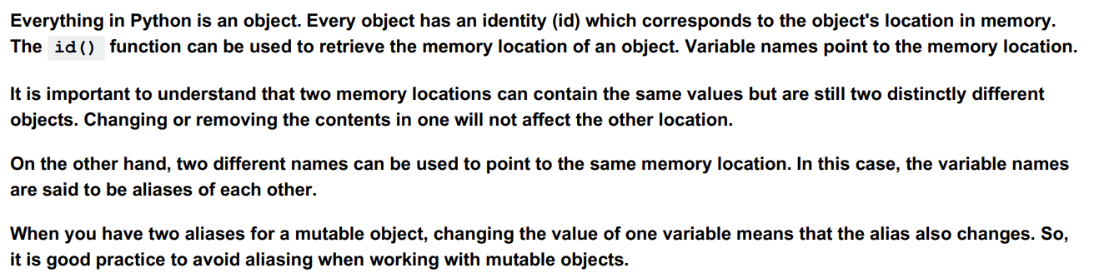

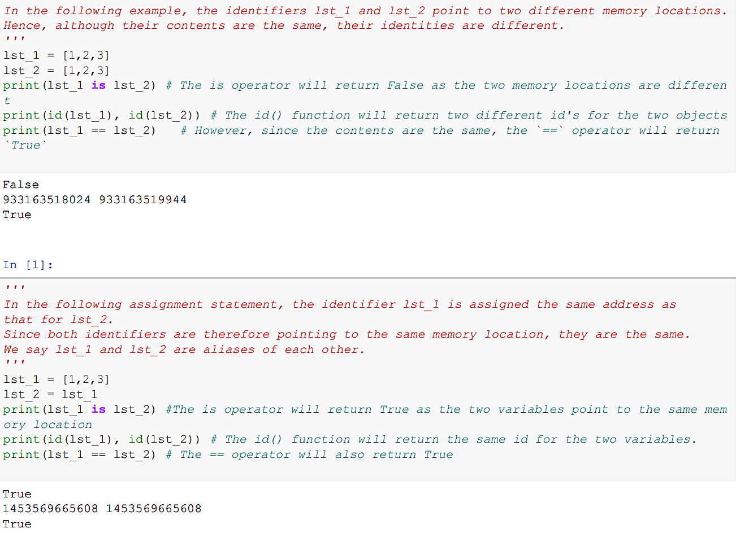

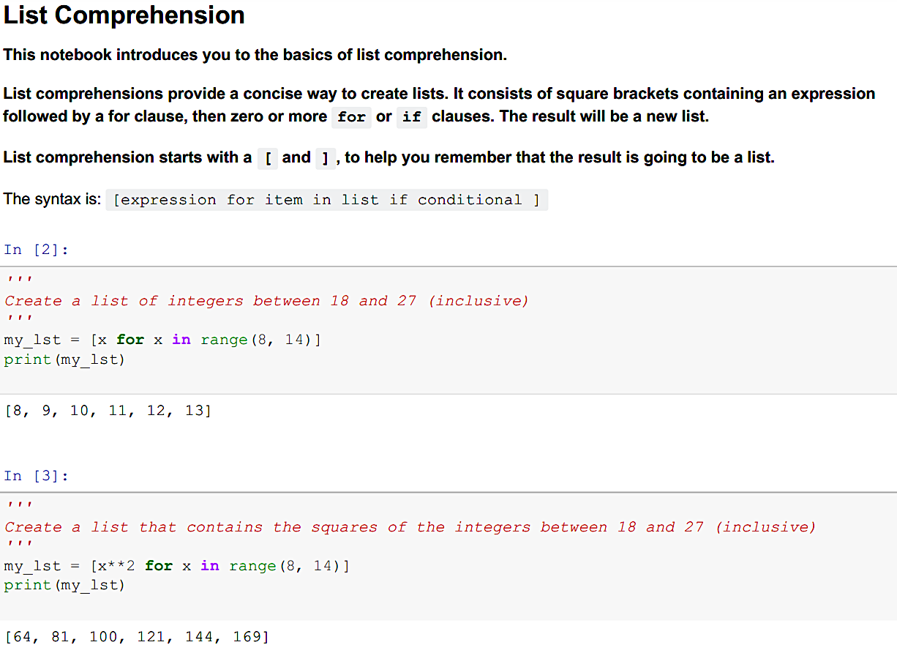

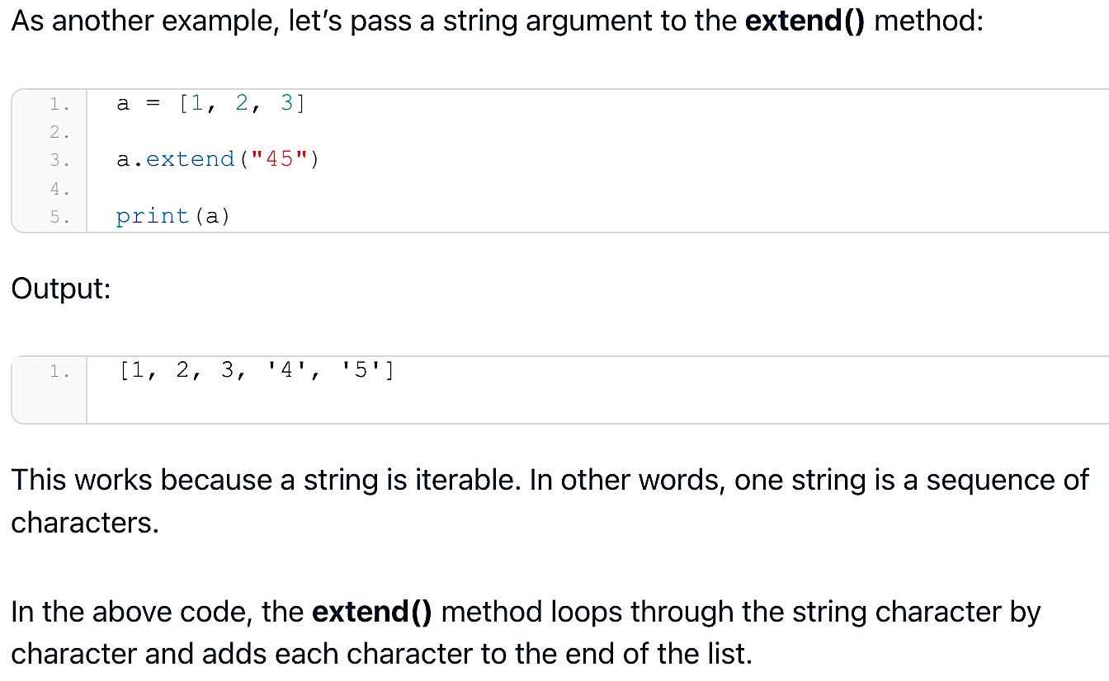

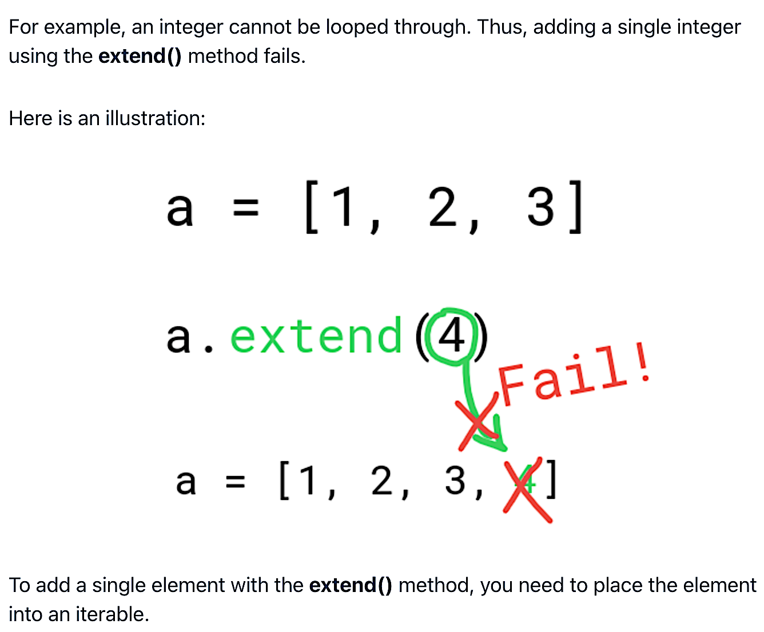

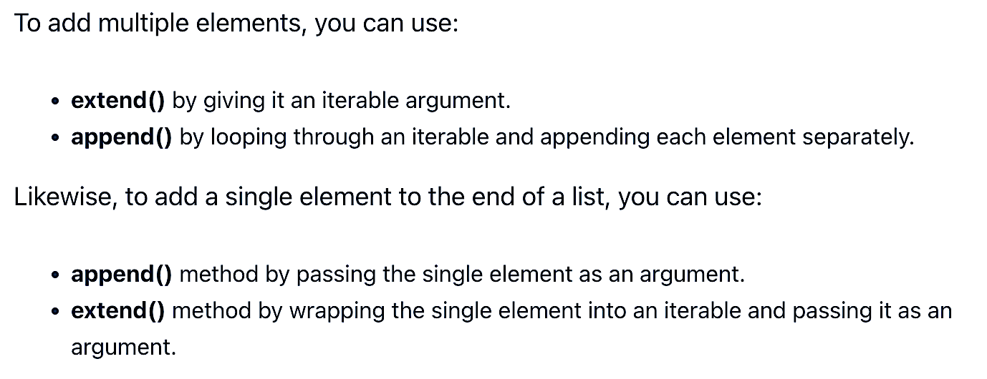

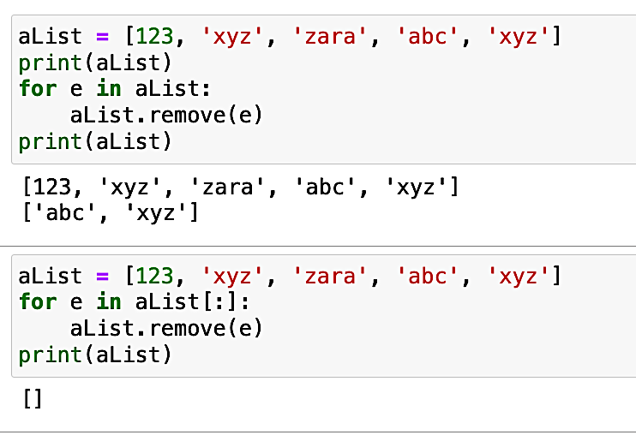

1st doesn’t remove all elements, and 2nd removes all elements.

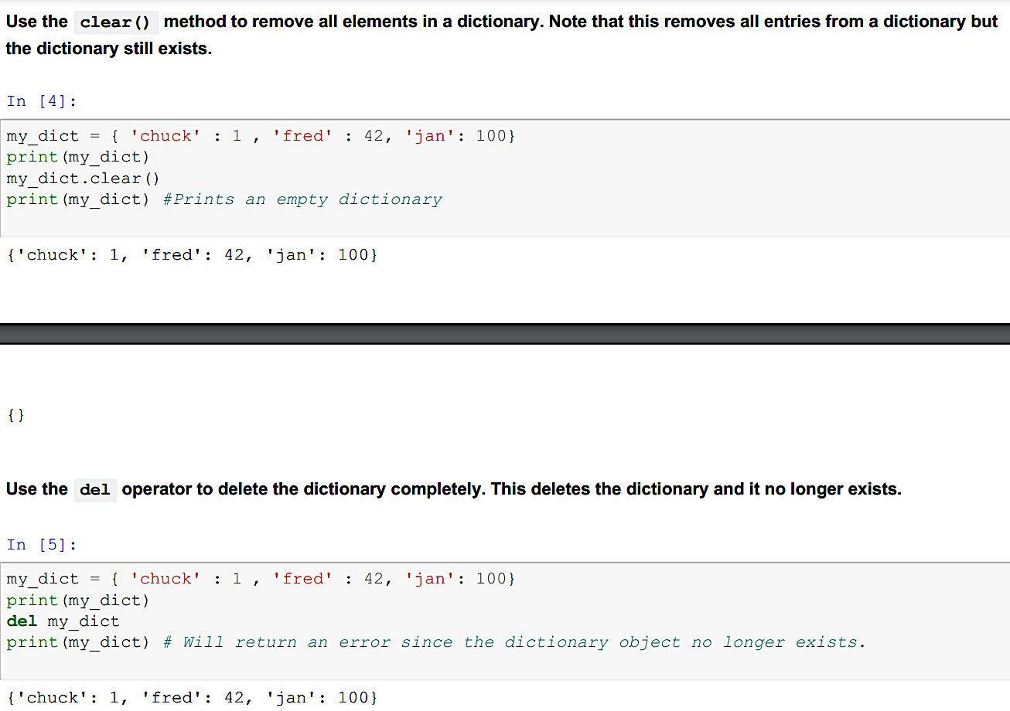

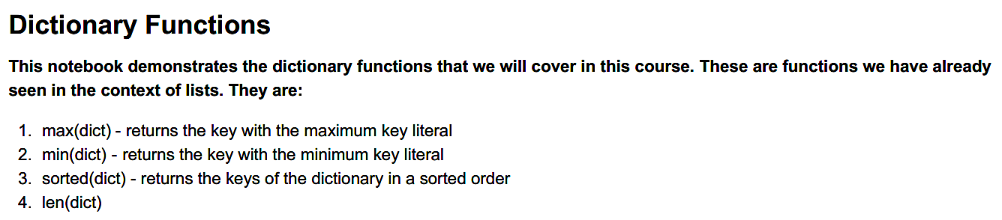

The max() function returns the key with the max value. Note that all the **keys in the dictionary** must be of the same type,

otherwise the use of the max() function will return an error.(Same for min)

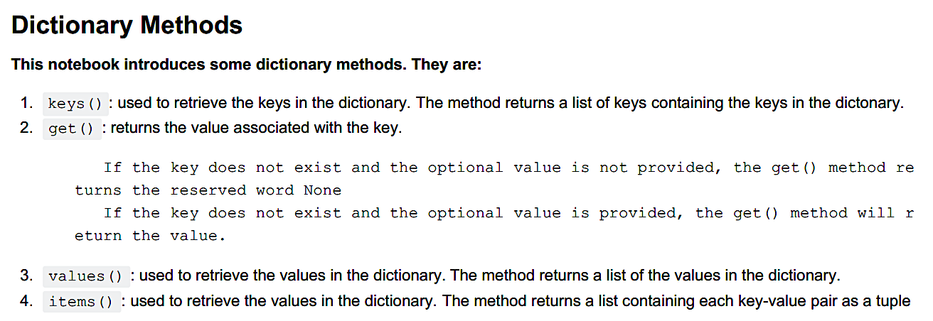

dictname.get(key, [value]) .

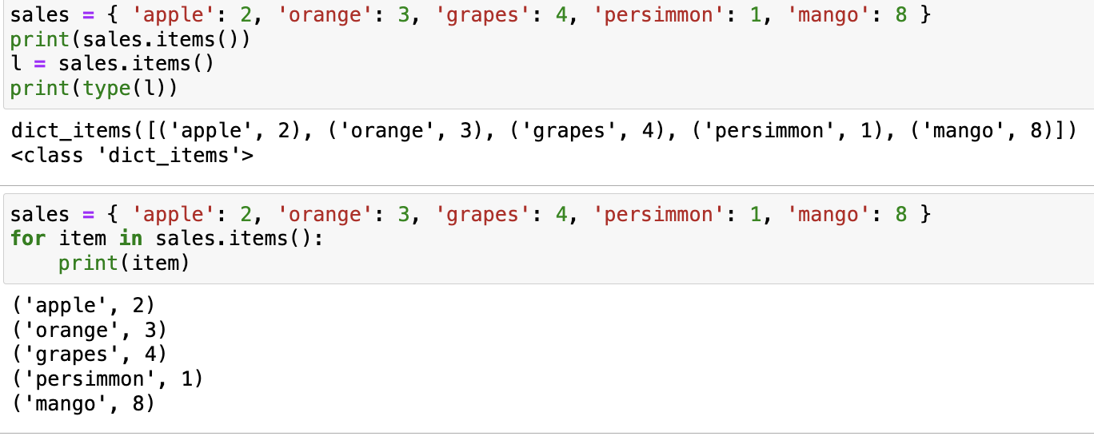

When item function is used in loop it is returned as tuple.

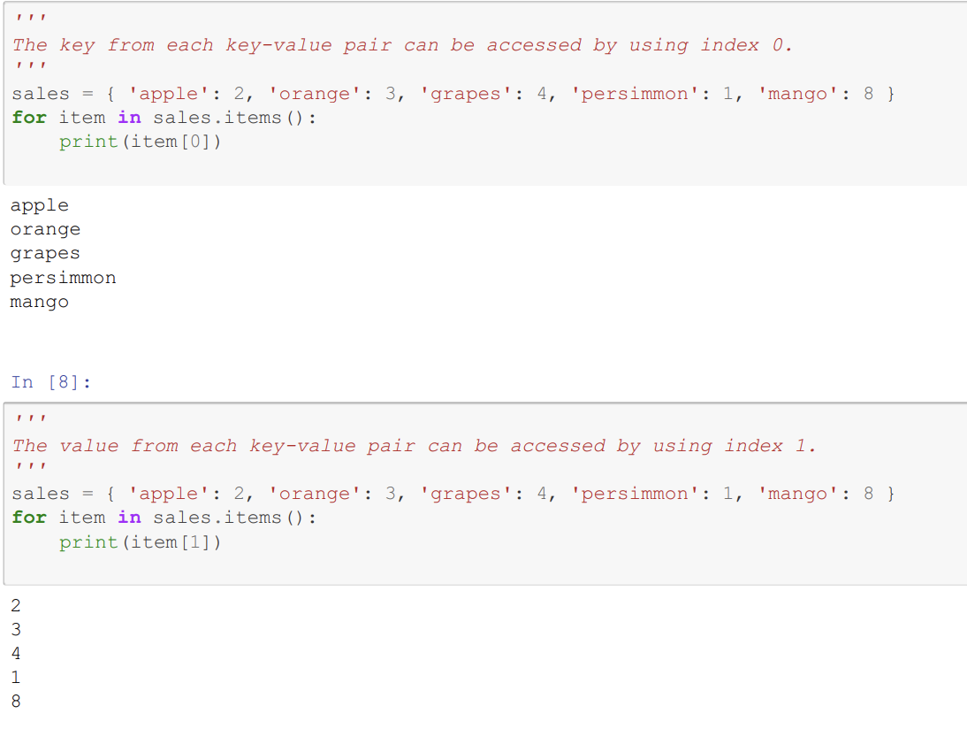

**We can use two iterator variables to access both the key and the value in one iteration. This is called unpacking.**

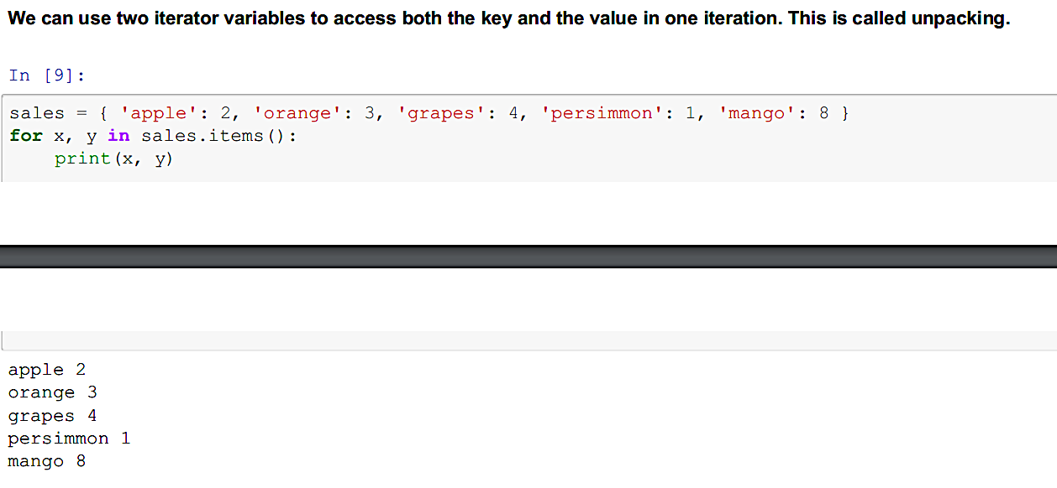

Tuples are very similar to lists except for one important difference: Tuples are immutable. That means that the contents of a

tuple cannot

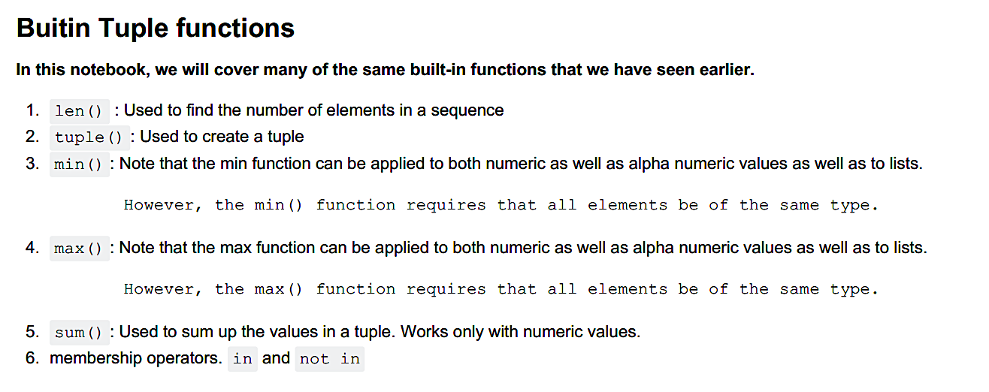

Means if max or min is being performed in that tupple there can either be numbers or letters  **NOT BOTH.**

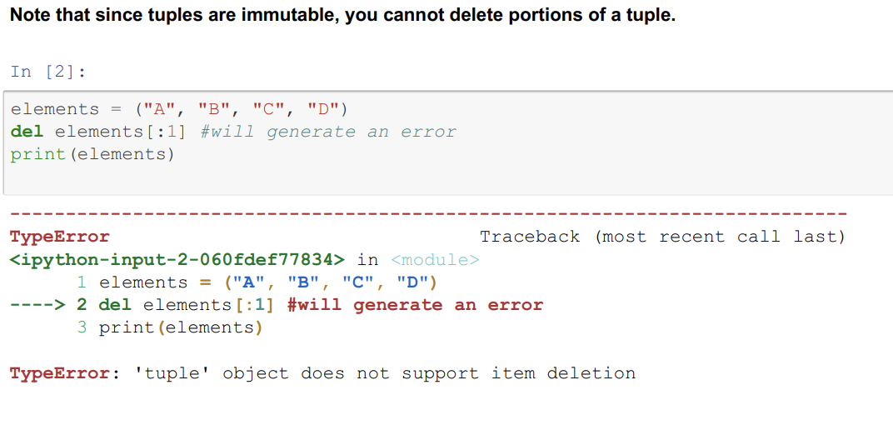

**DEL DOESN’T WORK ON** TUPLE

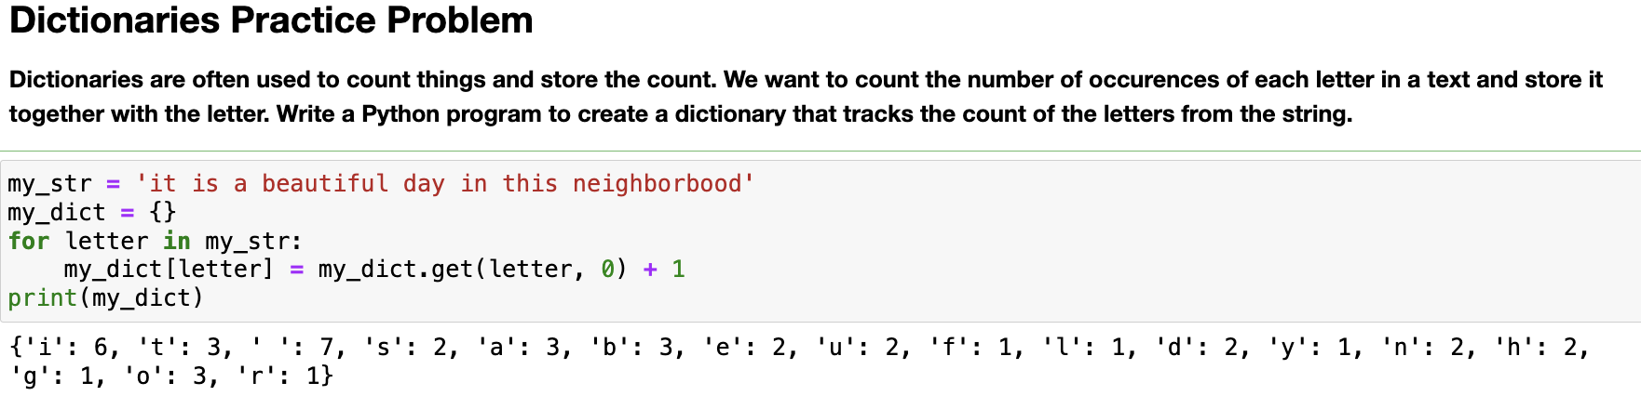

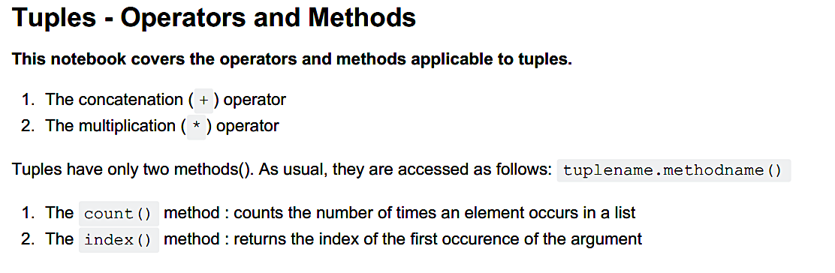

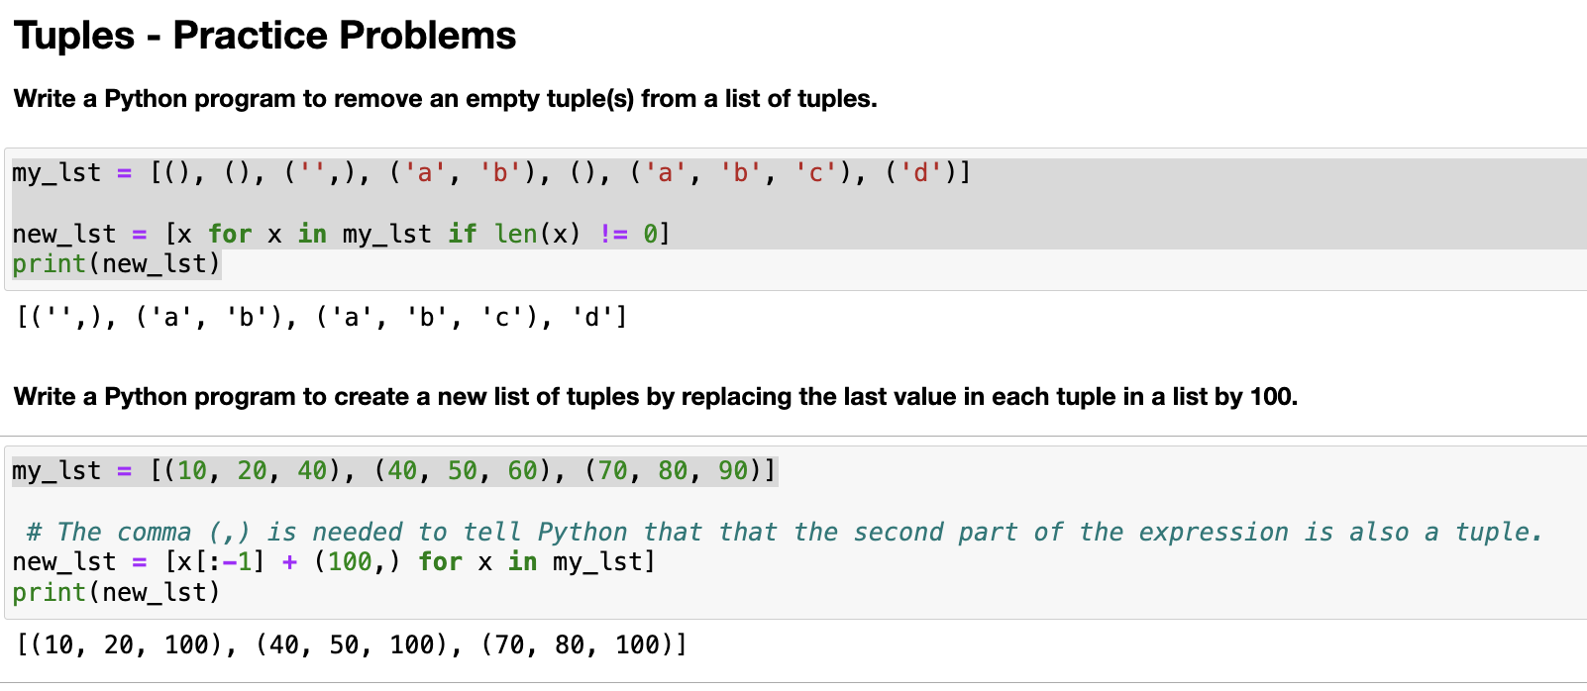

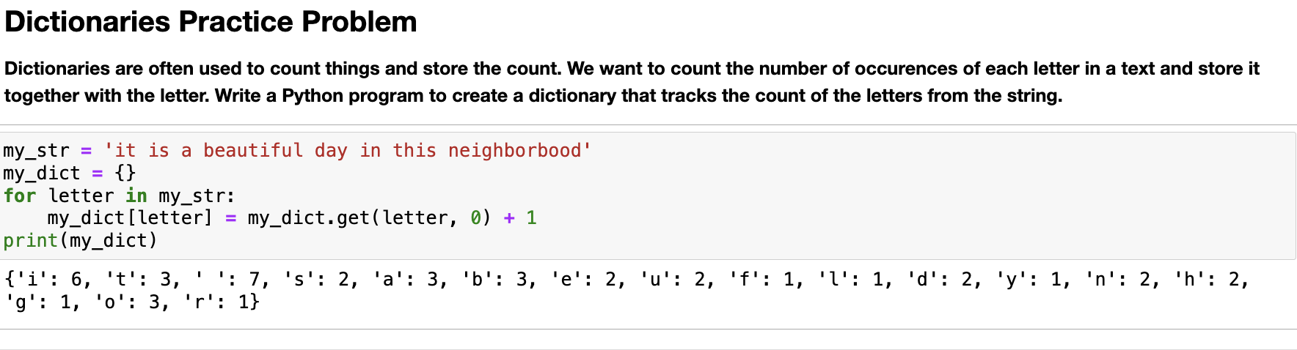

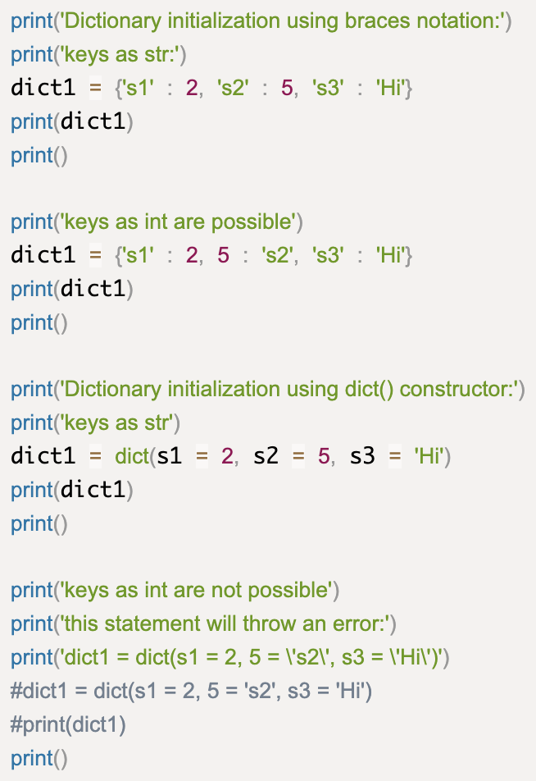

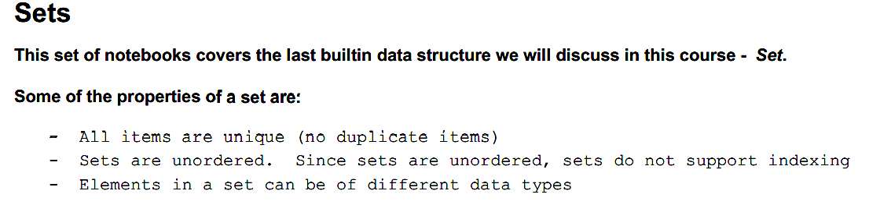

A set is created by using the set() function or placing all the elements within a

pair of curly braces. Note that when using

the set() function, the input argument must be an **iterable parameter.**

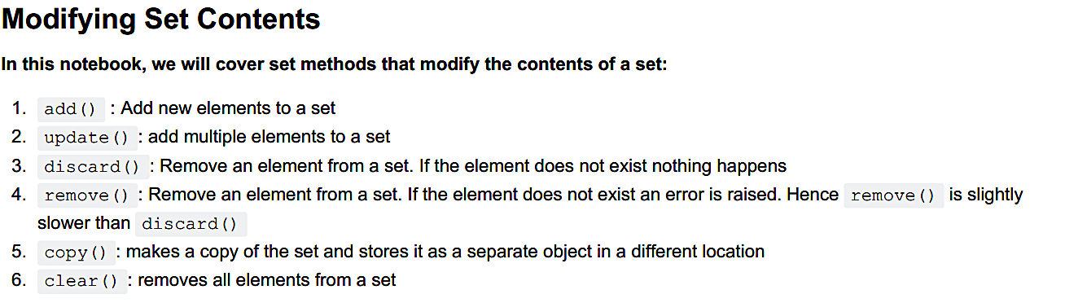

add – to add single object , update – multiple

To remove an element from a set, use the discard() method or the remove() method. Note that if the element does not

exist, the **discard() method will not raise an error**, but the **remove() method will.**

**Copy and id functions in set**

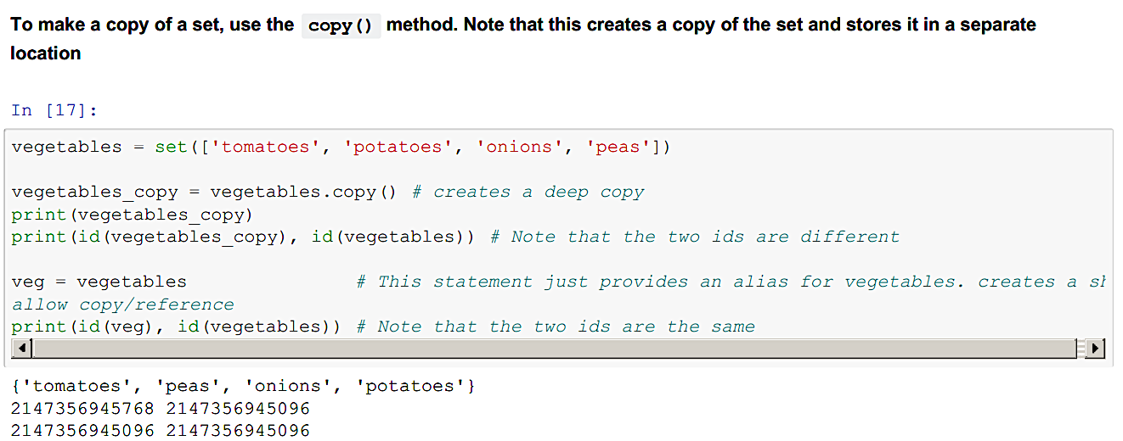

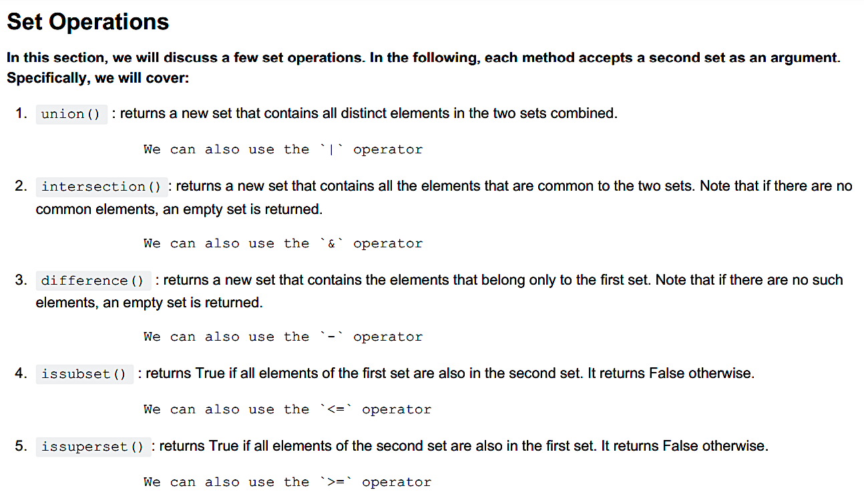

Union – all element,Intersection – common elements(if no common, returns empty set)

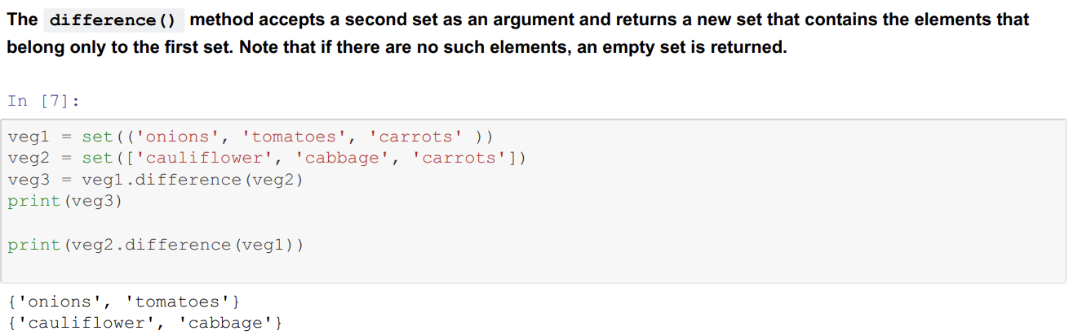

**Symmetric set:** (The **^** operator also does the same)

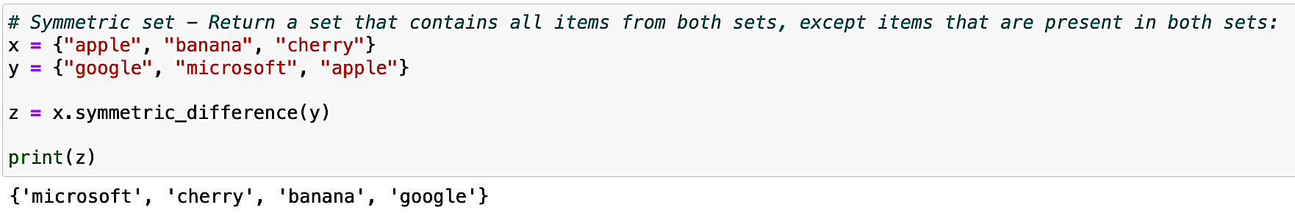

In **superset** – **all elements** of second set should be in the first.

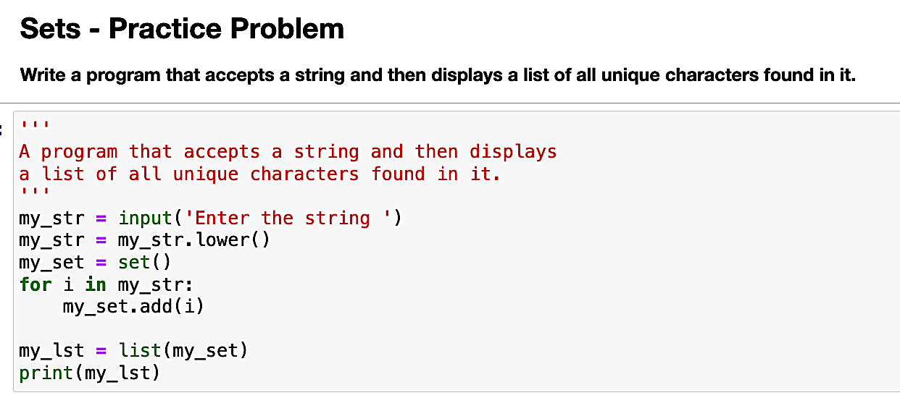

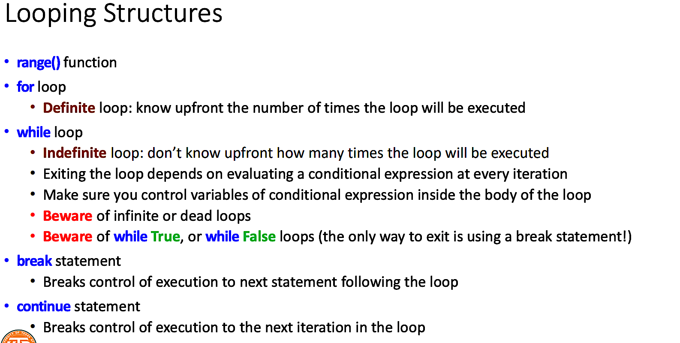

A loop body that will never execute even once is referred to as a **dead** l.

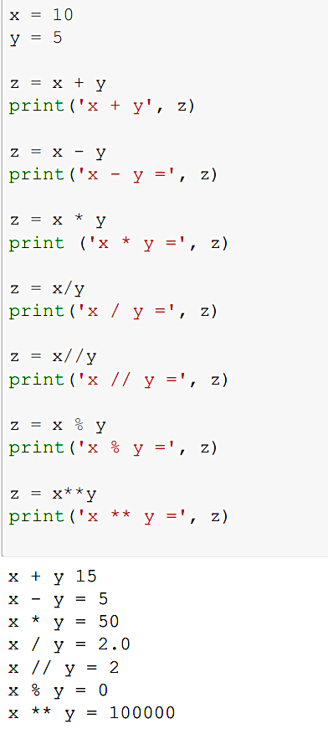 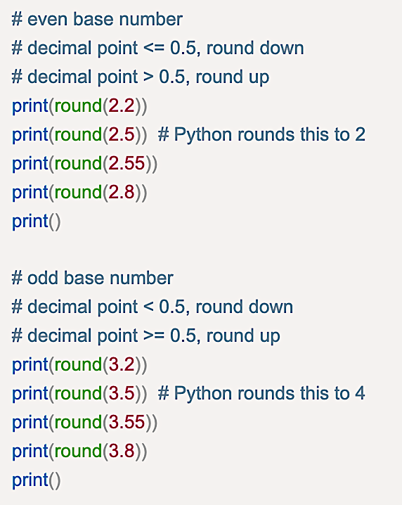

Difference between continue and pass.

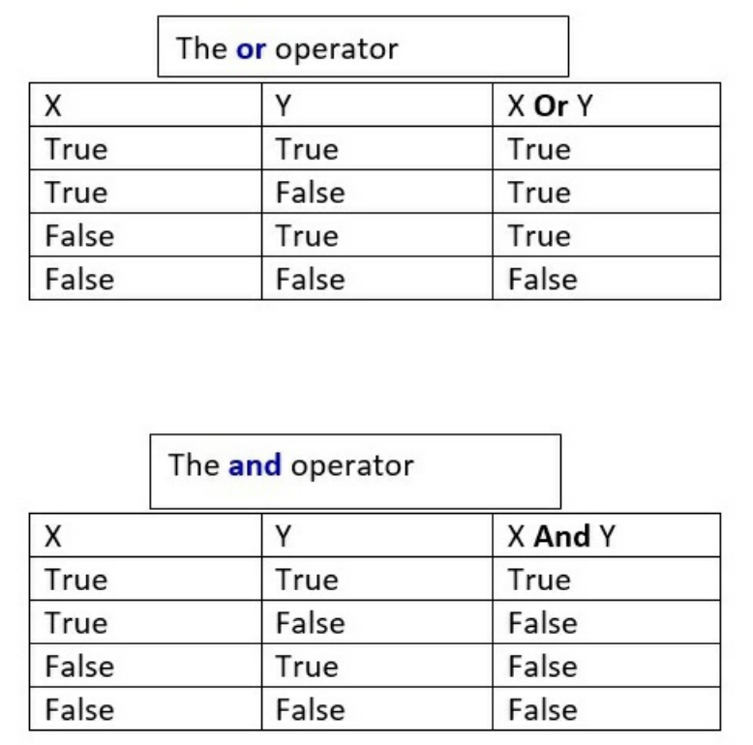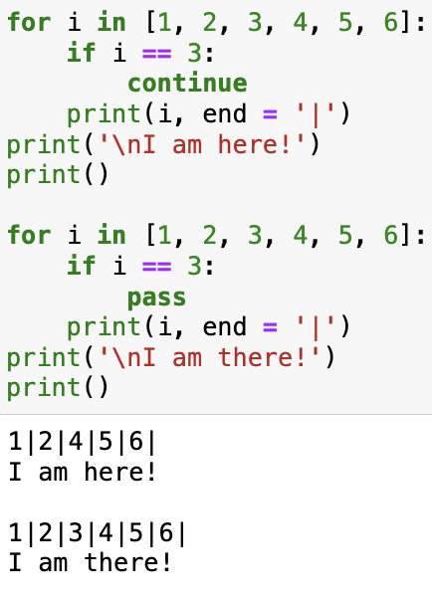

A function which returns a value is called a fruitful function

When function returns **multiple values** it is done in **TUPLE**.

**seed()** method to customize the start number of the random number generator. [ sys module = system specific information]

A **docstring** is a multiline comment. The line begins with a capital letter and ends with a period. [ __doc__ attribute]

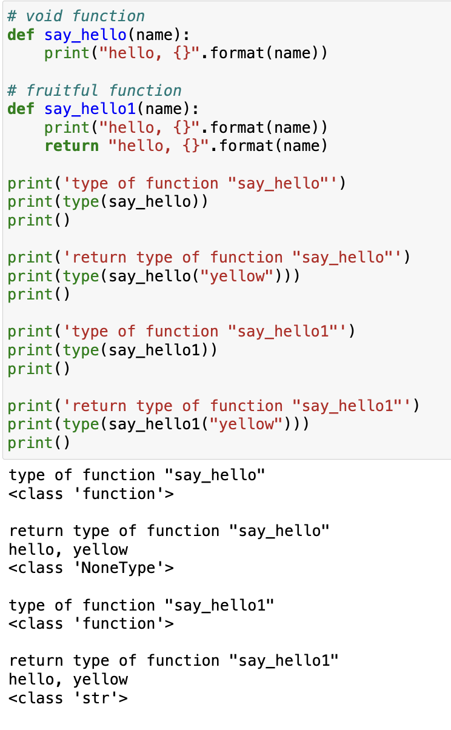

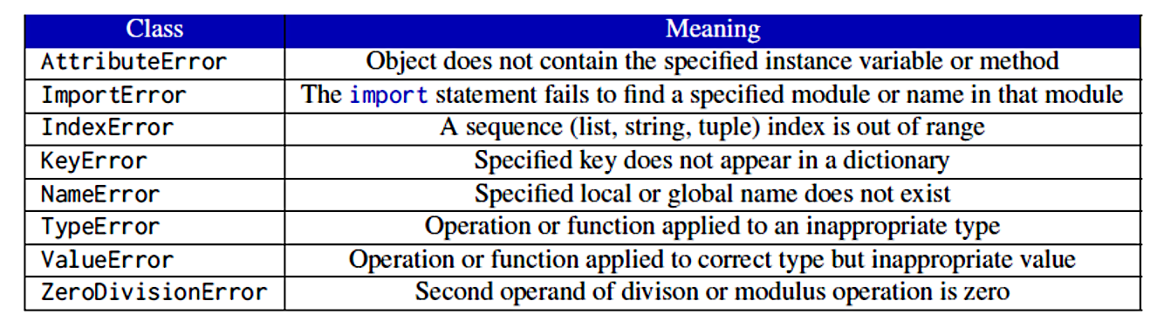

Note: an untyped except block(generic) has to be the last except block.

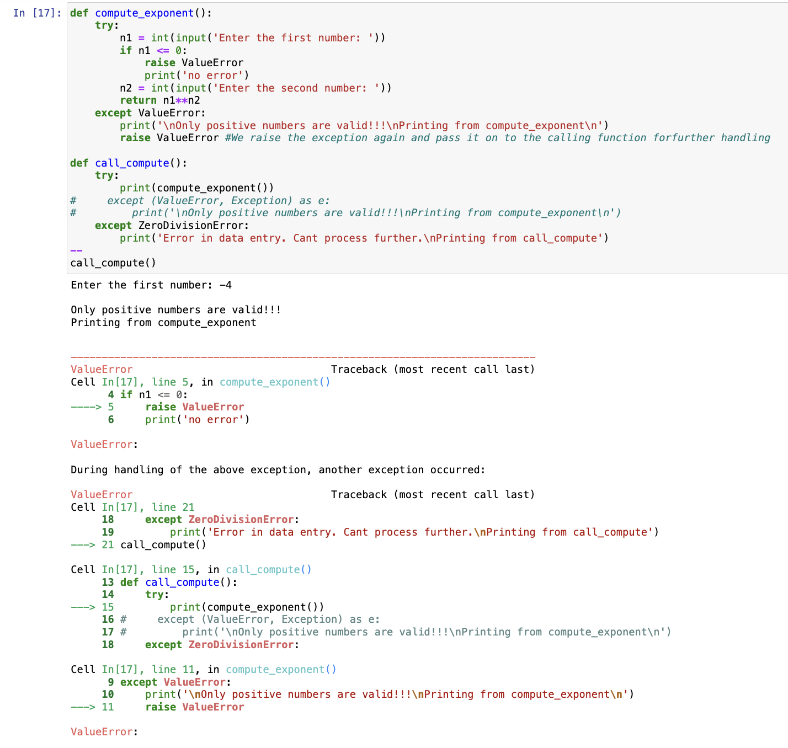

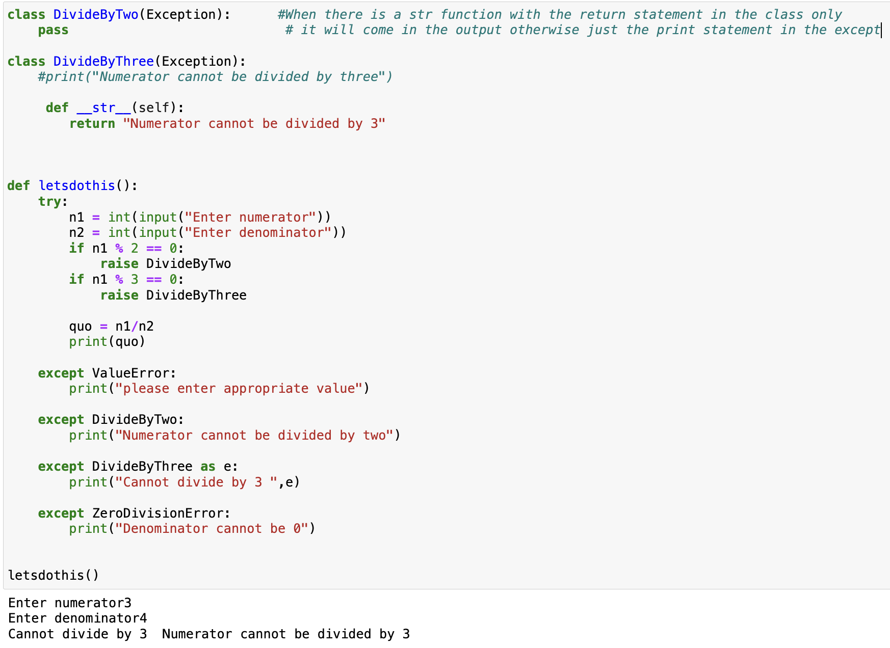

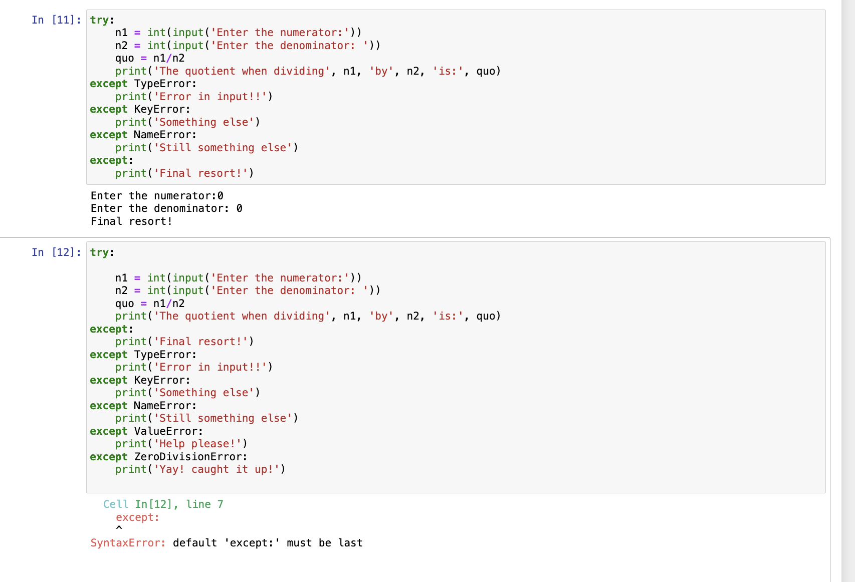

A try statement can have only one try block

The finally block should come after the catchall (untyped) exception

A **class** can be thought

of as a **blueprint for creating objects**. Each object is described by its attributes

and has behavior associated with it.

The **behavior** is captured through the methods of an object while the **attributes**

describe different properties of the object.  
An object of a class is also called an **instance** of a class and hence the attributes asscociated with an object are also

called **instance variables** .

Note that the single \_ character does not prevent direct access. It is just a convention to let other programmers know that this variable is not intended for direct access.

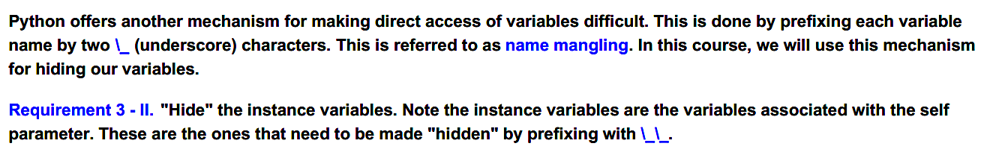

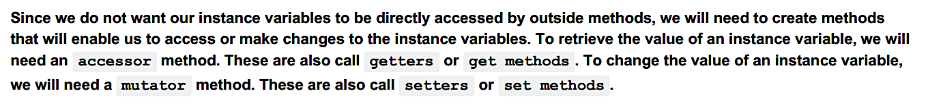

**__str__**

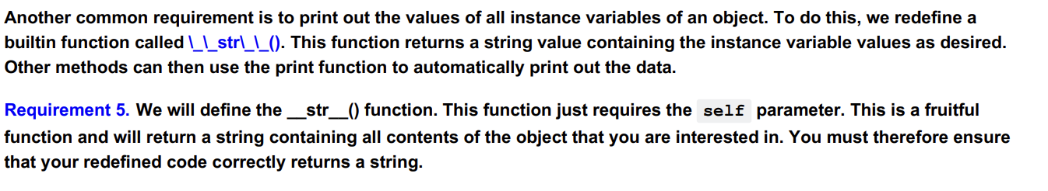

How can we print the hidden variables? (get or shown below)

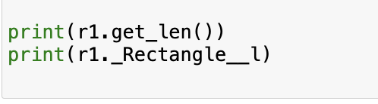

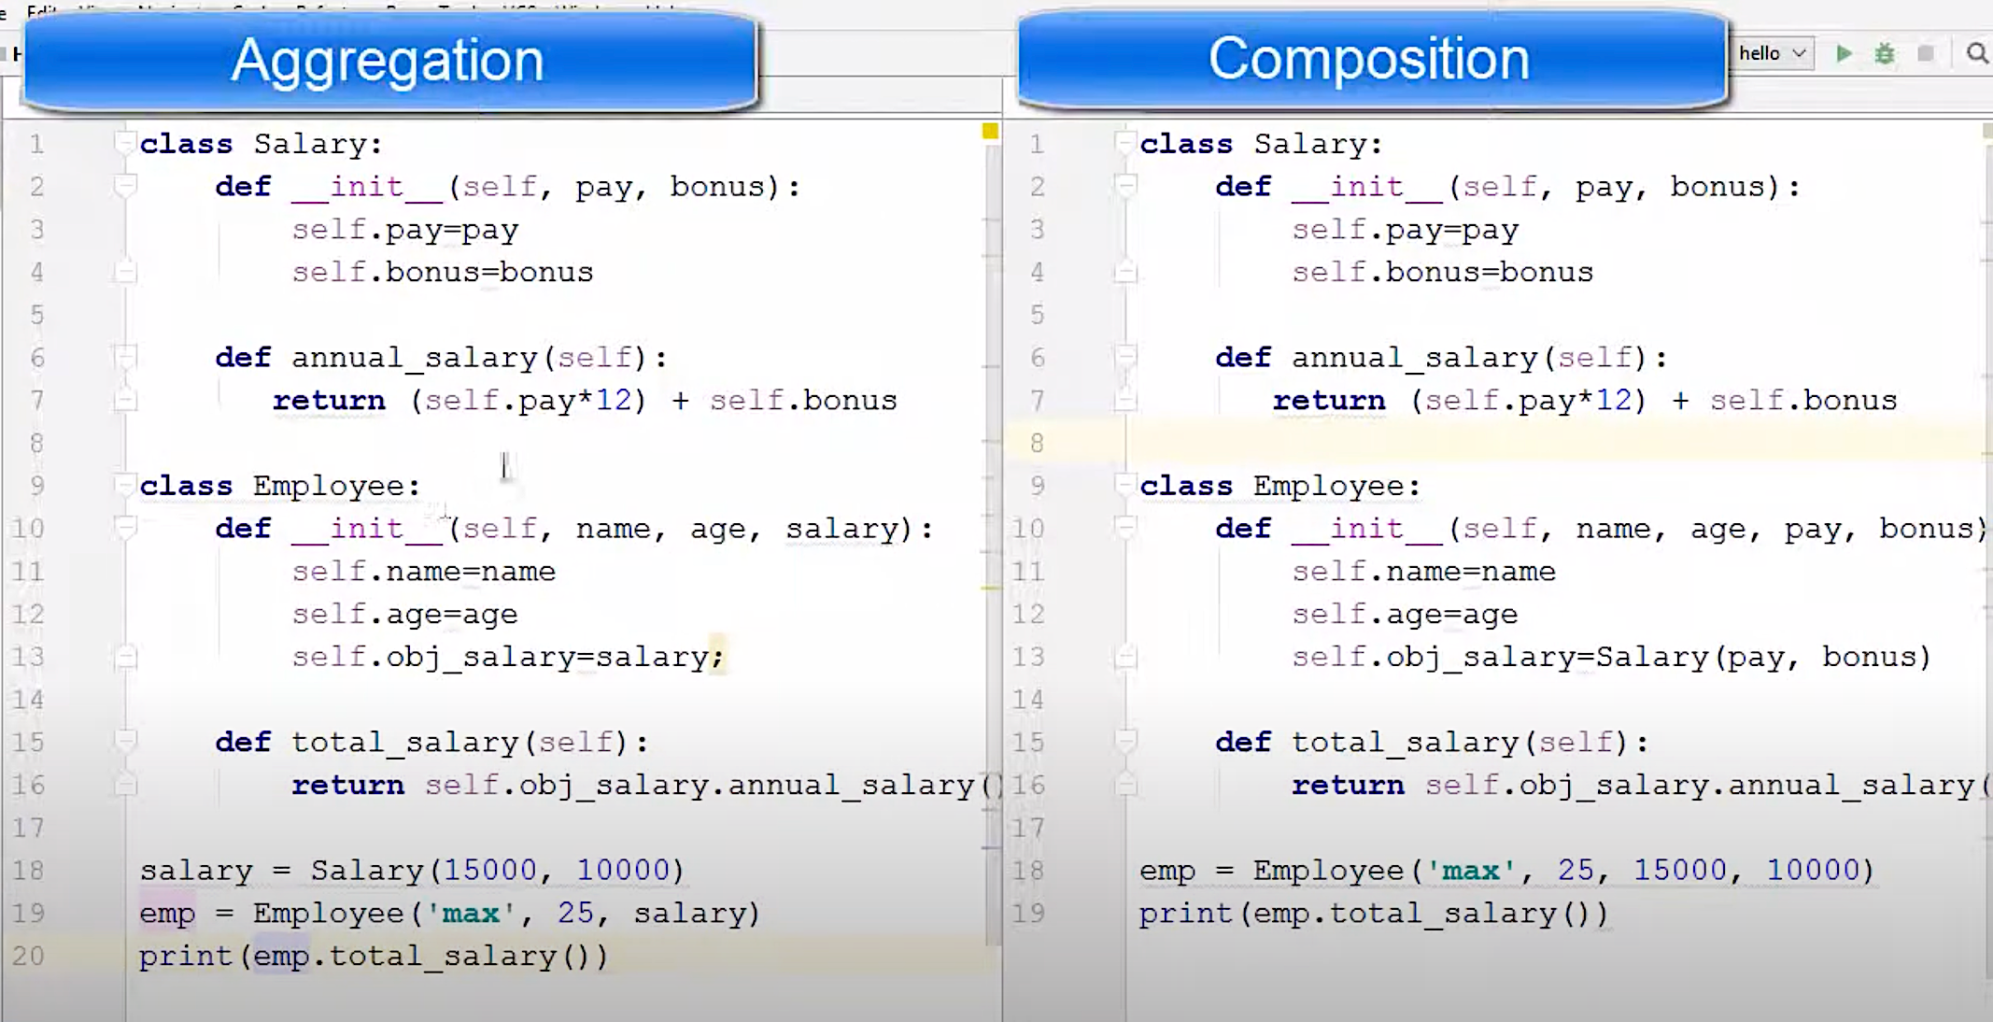

**Composition**: If the inner object is such that it cannot exist without the outer object, we call it composition . Composition means PART OF relationship

**Aggregation**: If the inner object can exist outside the outer object we call it aggregation

**Difference – comp | agree**

PART OF | HAS A

If emp obj deleted salary will be automatically deleted (salary is dependent on emp ) | not the same

Interdependent | Unidirectional

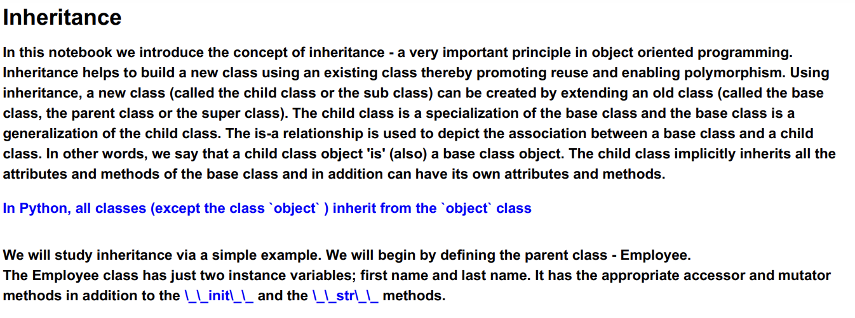

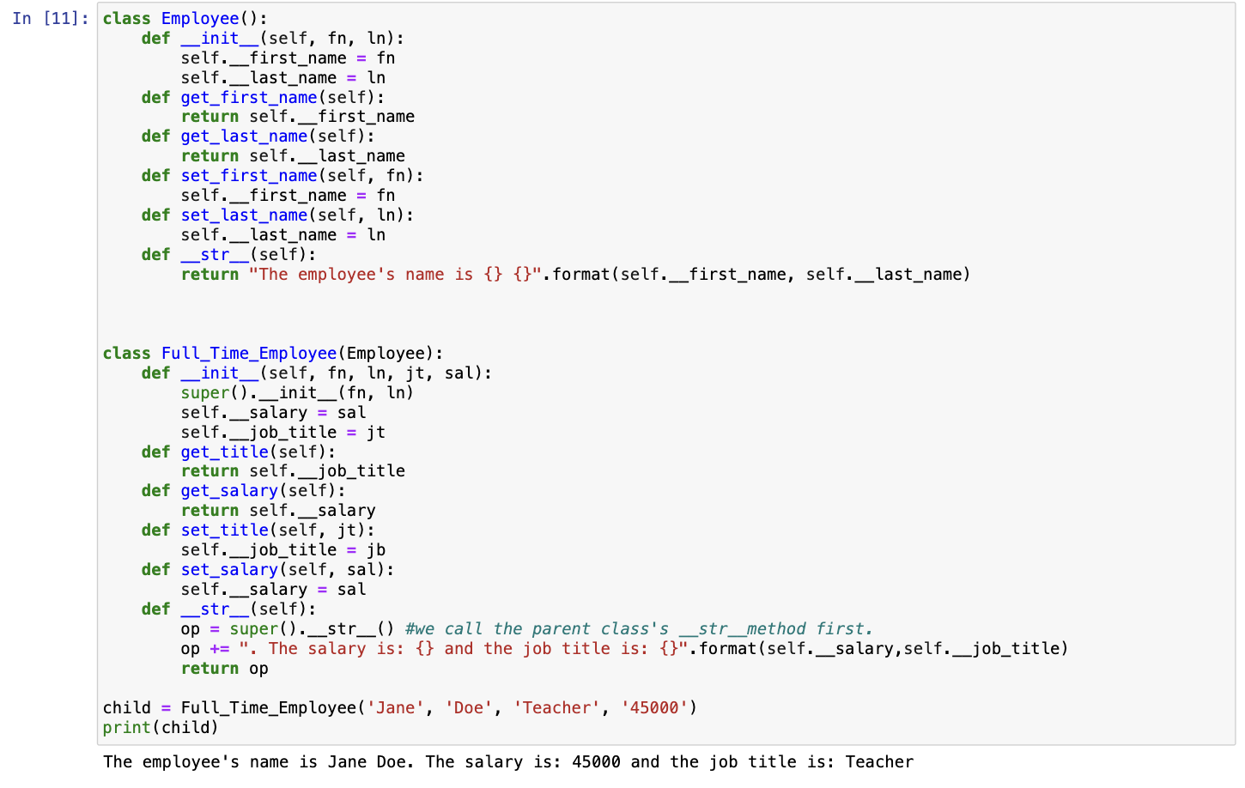

The **isinstance(a, B)** method returns True if object a is an instance of class B. It returns False otherwise.

The **issubclass(A, B)** method returns True if class A is a subclass of class B

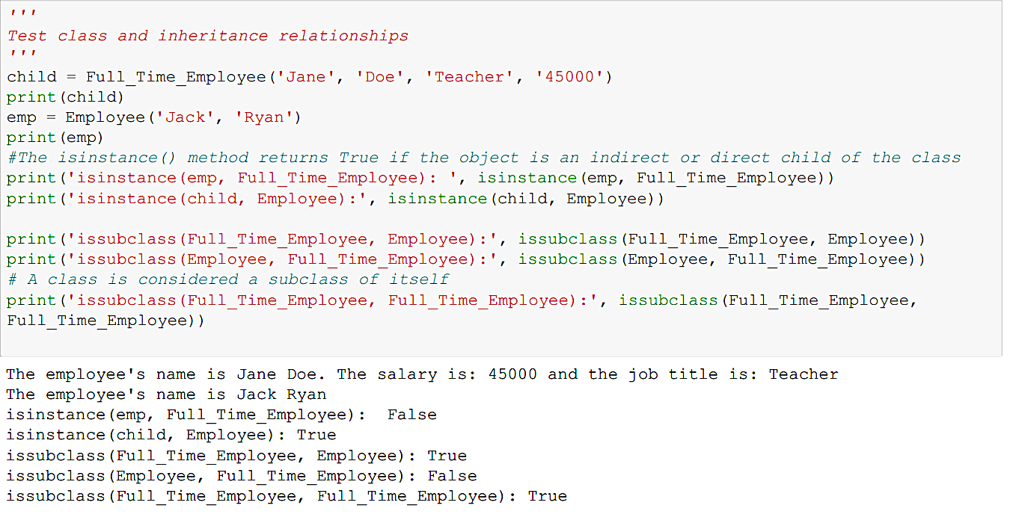

The term **polymorphism** (in object oriented programming) comes from the

fact that the same object can behave differently.

Any object which 'is-a' object of different classes, can exhibit polymorphic behavior.

**Polymorphism** enables the same object to be processed in different ways depending on the class.

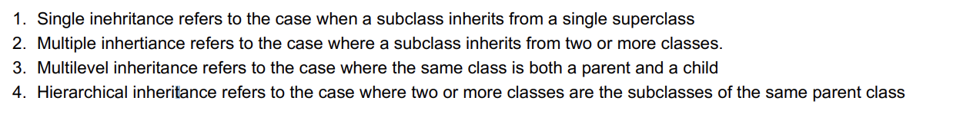

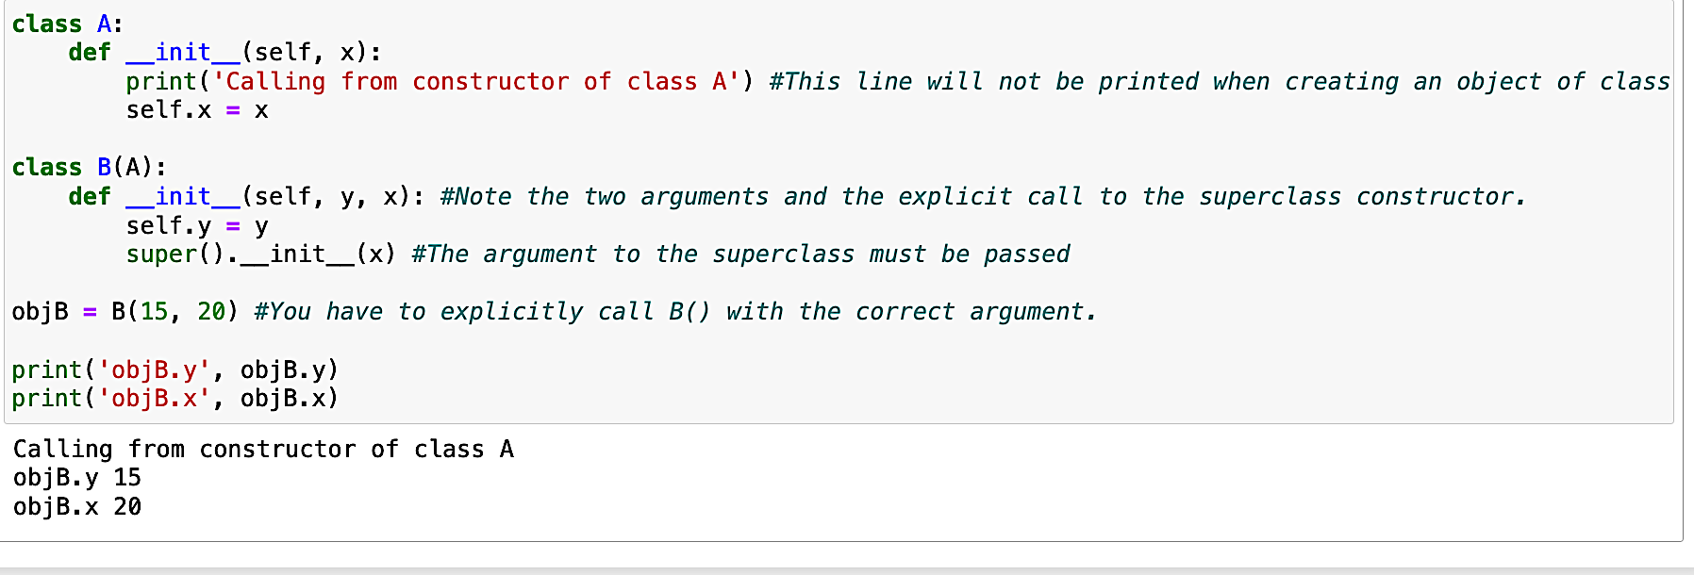

File  
The open() function returns a file object (also called a file handle) that contains methods for

working on the file.

W mode - The value of w for mode indicates that

we want to open this file for writing. Note that if the file exists and contains data, all that data will be wiped out and fresh data will be

written into the file.

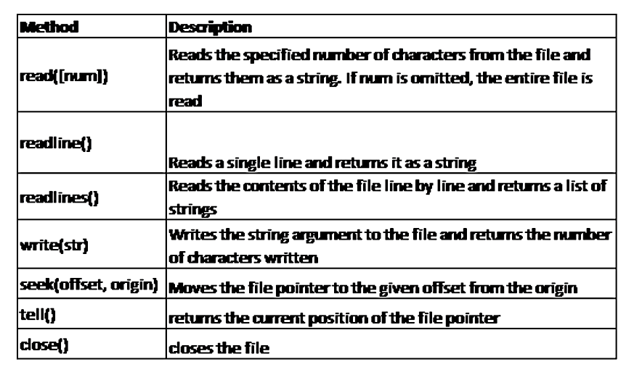

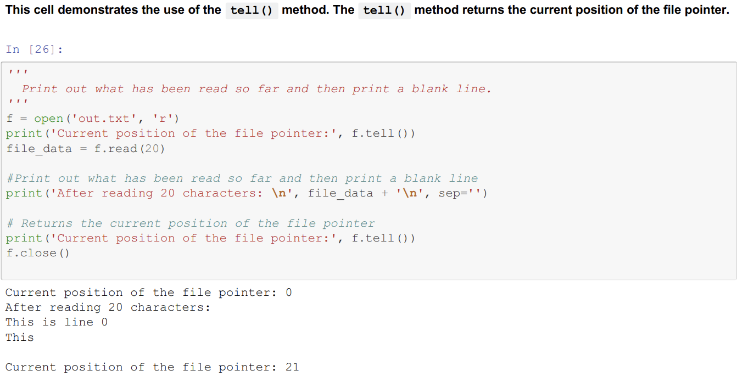

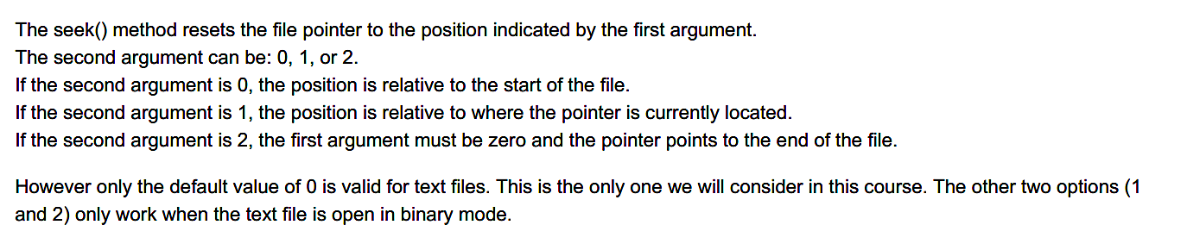

The readlines() method offers another way for reading lines from a text file. **It returns a list** where each line is an

element in the list.

Elements of the list are packed, and then unpacked using the 'for' loop iterator.

Readlinturns a list when you check the type it comes back as list.

**with/as construct**. Since it is important to always close a file after opening it, Python

offers a simpler way to ensure that the file is automatically closed when finished.

